**Q. Write a Problem Analysis Chart (PAC), Algorithm and Flowchart for checking whether a number is odd or even.**

PAC

|  |  |  |  |
| --- | --- | --- | --- |
| **Data** | **Processing** | **Output** | **Solution Alternatives** |
| Number | Check if the ‘Number’ is divisible by 2 | Print Even or Odd |  |

Algorithm

* Start
* Use variable **Number**
* Read **Number**
* if (**Number**%2==0)

Print “Even”

else

Print “Odd”

* Stop

Flowchart

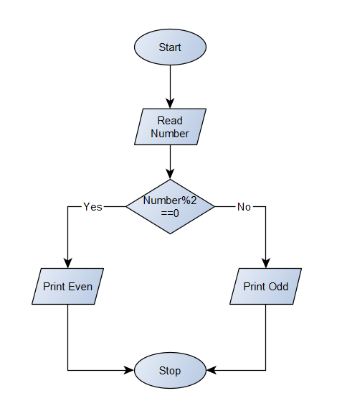

Python Program

Number = int(input(**"Enter a number : "**))  
if Number%2==0:  
 print(Number, **"is an even number"**)  
else:  
 print(Number, **"is an odd number"**)